13th October 2017

**FIA WTCC Returns following the long Summer break**

An exciting month is in store in the FIA World Touring Car Championship which has YOKOHAMA as official tyre supplier, with the battle for title glory raging on in Asia with the race of China and race of Japan coming up.

First is the visit to China and the all-new Ningbo International Speedpark from 13th – 15th October followed by the Race of Japan, which will take place at Twin Ring Motegi from 27th -29th October.

Tiago Monteiro heads the standings for the drivers’ crown, 12 points in front of Thed Björk, while Volvo Polestar is eight points to the good in the FIA World Touring Car Championship for Manufacturers.

Monteiro however who had suffered a crash during a test in Barcelona is still recovering and unfortunately will miss the Race of China. As a result the whole community of the WTCC at all levels, including organisers, teams and Championship partners have all expressed their best wishes to the Portuguese driver and wish him the speediest of recoveries.

Former world champion and team-mate Gabriele Tarquini has been announced as stand-in for the Championship leader for the race in China.

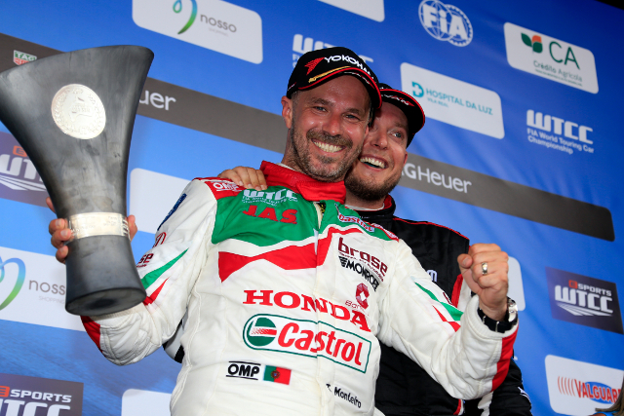

*Tiago Monteiro at the Race of Portugal Best wishes and speedy recovery Tiago!*